Contents
Data Sources 2
Pipeline and Methodology 2
Data Preprocessing 2
Segmentation Model 2
Model Components 3
Model Parameters 3
U-Net with ResNet Backbone 3
Training 3
Training Results 4
U-Net with Resnet backbone 4
Model Test Performance 4
Conclusion 5

MRI Segmentation

Data Sources
The dataset used for this project is sourced from Figshare. It contains MRI scans categorized into three tumor types:
- Glioma: A type of tumor that occurs in the brain and spinal cord.
- Pituitary Tumor: A tumor found in the pituitary gland, which can affect hormone production.
- Meningioma: A tumor that arises from the meninges, the membranes surrounding the brain and spinal cord.
This dataset provides a diverse set of MRI images, allowing the model to learn and generalize across different tumor types.
Data Link: https://figshare.com/articles/dataset/brain_tumor_dataset/1512427?file=51340418

Pipeline and Methodology

Data Preprocessing
- Normalization: Standardized pixel values to improve model stability.
- Augmentation: Applied transformations like rotation, flipping, and contrast adjustment to enhance model robustness.
- Splitting: Divided data into training (70%), validation (15%), and testing (15%).

Segmentation Model
The segmentation process is based on an encoder-decoder architecture, designed to efficiently extract features and reconstruct accurate segmentation maps. Two separate models were implemented for comparison:
- U-Net with ResNet Backbone: An enhanced version of U-Net, utilizing a pre-trained ResNet as the encoder for better feature extraction and improved segmentation accuracy.

Model Components
- Encoder: Pre-trained CNNs (ResNet-based U-Net) extract hierarchical feature representations.
- Decoder: Upsampling layers reconstruct the segmentation map from extracted features.
- Skip Connections: Used to retain spatial information and refine segmentation boundaries.

Model Parameters
The number of trainable and non-trainable parameters for each model is as follows:

U-Net with ResNet Backbone
- Total Parameters: 19,417,539 (74.07 MB)
- Trainable Parameters: 19,386,947 (73.96 MB)
- Non-Trainable Parameters: 30,592 (119.50 KB)

Training
- Loss Function: Dice loss to handle class imbalance in segmentation.
- Optimizer: Adam optimizer with a learning rate scheduler.
- Evaluation Metrics:
  - Dice Similarity Coefficient (DSC)
  - IoU (Intersection over Union)
  - Pixel-wise Accuracy

Training Results

U-Net with Resnet backbone
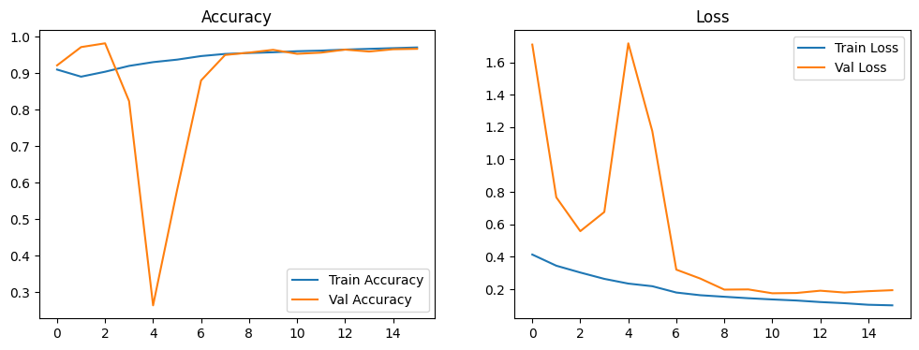
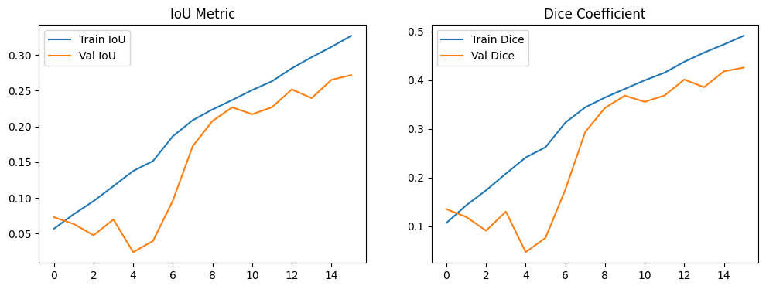

Model Test Performance
Both models were tested separately to evaluate performance differences in terms of accuracy, segmentation quality, and computational efficiency.
Model | Test Accuracy | Test IoU | Test Dice Coefficient
U-Net (Trained previously) | 0.90 | 0.08 | 0.15
U-Net with ResNet backbone | 0.96 | 0.22 | 0.36

Conclusion
The results indicate that the U-Net with ResNet Backbone significantly outperforms the standard U-Net in all evaluation metrics. The higher accuracy (0.96 vs. 0.90), IoU (0.22 vs. 0.08), and Dice Coefficient (0.36 vs. 0.15) suggest that integrating a ResNet backbone improves feature extraction, leading to better segmentation quality.
While U-Net provides reasonable performance, its segmentation maps may lack precision due to limited feature extraction capabilities. The ResNet-based model effectively captures deeper contextual information, resulting in more accurate tumor boundary delineation. Based on these findings, the U-Net with ResNet Backbone is recommended for tumor segmentation tasks.

